The below media advisory was distributed to media this morning:
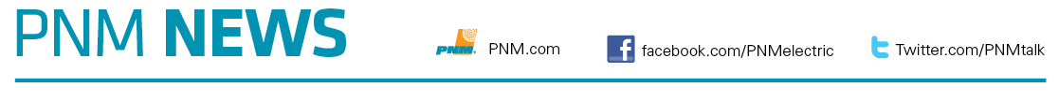

MEDIA ADVISORY: June 22, 2020
Contact: Shannon Jackson • 505-514-3978 cell • Shannon.Jackson@pnm.com

PNM Helping Hand Tuesdays helps low-income customers struggling to pay
3-week initiative focuses on bringing a sigh of relief to many New Mexicans
(Albuquerque, NM) – A helping hand can lift a weight off the shoulders of many New Mexicans who are struggling to pay their electric bill. Through the PNM Helping Hand Tuesdays initiative, PNM is urging low-income customers who are facing an unexpected financial hardship to call 505-967-8045 on Tuesdays, through July 7, for up to $150 to be applied towards their PNM bill.
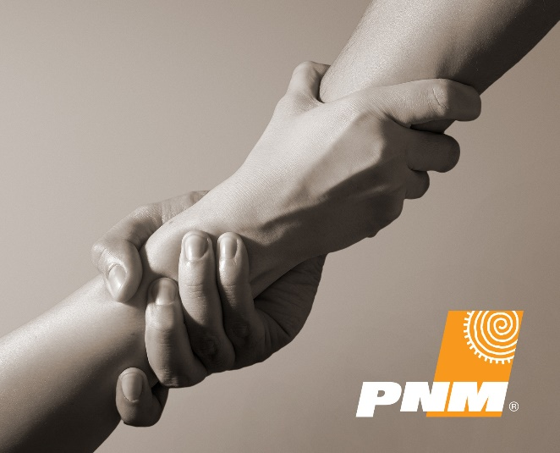
Who: PNM low-income customers in New Mexico
What: In tough economic times, sometimes people need a helping hand to make ends meet. PNM Helping Hand Tuesdays is paying up to $150 towards electric bills for low-income customers struggling to pay. Amount is applied to account within 2-days after receiving required verification.

When: Tuesday, June 23 from 7:30 a.m. – 6 p.m.
Tuesday, June 30, from 7:30 a.m. – 6 p.m.
Tuesday, July 7, from 7:30 a.m. – 6 p.m.

Where: By phone only, 505-967-8045
Cost: Free. This is not a loan; it is a credit applied to the PNM bill of qualified low-income customers
Must provide digital copies of the following to receive help with PNM bills:
- Proof of income and identification for everyone living in the home
- Your LIHEAP approval letter dated either 2019 or 2020 from NM Dept of Human Services
- If no income, then proof of no income is required. Accepted is proof of food stamps.
- Your PNM Bill

About PNM
With headquarters in Albuquerque, PNM is the largest electricity provider in New Mexico, serving more than 530,000 customers in dozens of communities across the state. PNM is a subsidiary of PNM Resources, an energy holding company also headquartered in Albuquerque. For more information, visit PNM.com.
###

