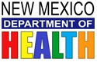
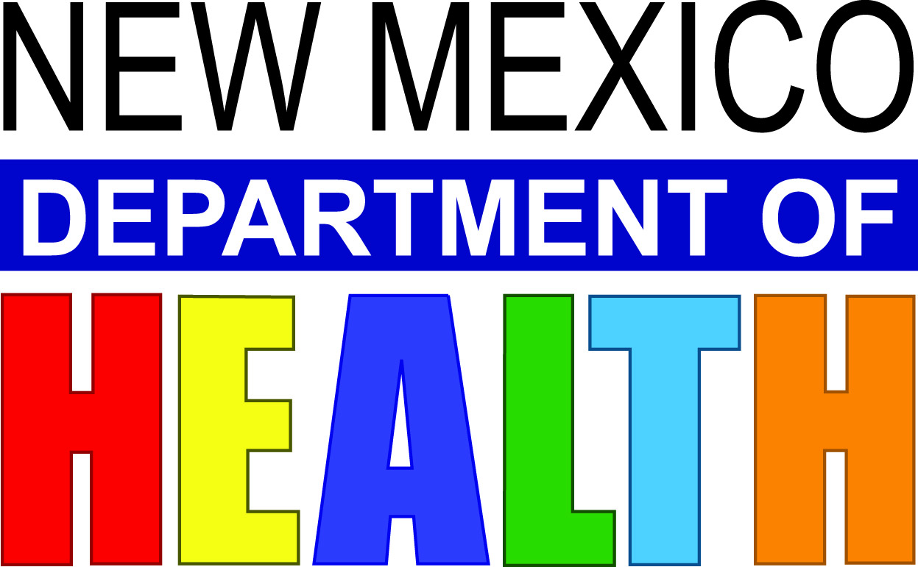
HIDALGO COUNTY PUBLIC HEALTH OFFICE WILL BE
HOSTING 3 COVID-19 TESTING EVENTS

All events will be held at: LORDSBURG CITY HALL
409 W. Wabash Street, Lordsburg, NM

PRE-REGISTRATION IS REQUIRED www.cvtestreg.nmhealth.org

Thursday, September 10, 2020 from 7:00 AM – 11:00 AM
Saturday, September 12, 2020 from 7:00 AM – 11:00 AM
Thursday, September 17, 2020 from 3:00 PM – 7:00 PM

This is a voluntary test and residents are encouraged to get tested if:

They are ill, experiencing symptoms such as shortness of breath, cough or fever

Someone who has recently traveled outside of New Mexico

They are asymptomatic but had close contact to a confirmed positive person

They are a resident in a congregant setting such as a nursing home, homeless shelter, group home or detention center

First responders (Police Officers, EMS, Firefighters, Border Patrol)

Essential workers from Town of Lordsburg, Hidalgo County, Grocery store employees, Utility workers, Health Care Workers, etc.

Everyone must register on the DOH link-- www.cvtestreg.nmhealth.org

Please call Hidalgo County Public Health Office for assistance with registration
or if you have any questions, 575-542-9391

Coronavirus Hotline at 1-855-600-3453

