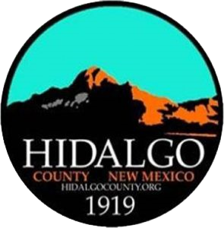
HIDALGO COUNTY COMMISSION
SPECIAL MEETING AGENDA
DECEMBER 13, 2023 at 7 PM or
immediately following adjournment of the regular meeting
COMMISSION CHAMBERS
305 PYRAMID STREET
LORDSBURG, NEW MEXICO

- CALL MEETING to ORDER and WELCOME

  - Pledge of Allegiance
  - Approval of Agenda

- MISCELLANEOUS
  - Appointment of members to the PLAC Board

- ADJOURN

If you are an individual with a disability who is in need of a reader, amplifier, qualified sign language interpreter, or any other form of auxiliary aid or service to attend or participate in the hearing or meeting, please contact County Manager Tisha Green at tisha.green@hidalgocounty.org or (575) 542-9428 least one (1) week prior to the meeting or as soon as possible. Public documents, including the agenda and minutes, can be provided in various accessible formats. Please contact County Manager Tisha Green if a summary or other type of accessible format is needed.

Notice: Ministers or laypersons, of any persuasion, are invited to lead the County Commission in an invocation at regular meetings by signing up on a first-come-first-serve basis by contacting County Manager Tisha Green, at 575.542.9428 or tisha.green@hidalgocounty.org . The County of Hidalgo welcomes any invocation, religious or secular, regardless of the basis of faith, belief or doctrine of practice. Invocations are limited to 1 minute and non-county personnel are limited to leading 1 invocation per year. Individuals are not required to participate in the invocation.

