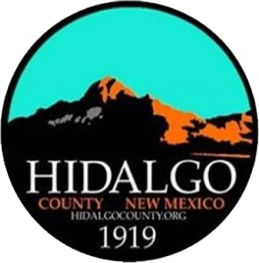

HIDALGO COUNTY COMMISSION
SPECIAL MEETING AGENDA
JULY 2, 2026, at 5:30 PM
ANIMAS PUBLIC SCHOOLS AUDITORIUM
1 PANTHER BLVD.
ANIMAS, NEW MEXICO

- CALL MEETING to ORDER and WELCOME
  - Invocation
  - Pledge of Allegiance
  - Approval of Agenda

- PUBLIC COMMENT
During this portion of our meeting, we welcome your suggestions and want to hear your concerns. This is not a question and answer period; speakers will be limited to three (3) minutes. The County Commission is not able to take action on matters discussed during public comment. Speakers are requested to state their name for the record.

- TOWNHALL DISCUSSION
  - Geothermal Development Process-BLM-Cody McCall
  - Geothermal—Zanskar Representative
  - Mining Process—BLM Representative
  - Data Centers, Mining Development, Geothermal Development and Direct Supporting Infrastructure

- UPCOMING MEETINGS
  - Regular Meeting, July 8, 2026

- ADJOURN

If you are an individual with a disability who is in need of a reader, amplifier, qualified sign language interpreter, or any other form of auxiliary aid or service to attend or participate in the hearing or meeting, please contact County Manager Tisha Green at tisha.green@hidalgocounty.org or (575) 542-9428 least one (1) week prior to the meeting or as soon as possible. Public documents, including the agenda and minutes, can be provided in various accessible formats. Please contact County Manager Tisha Green if a summary or other type of accessible format is needed.

Notice: Ministers or laypersons, of any persuasion, are invited to lead the County Commission in an invocation at regular meetings by signing up on a first-come-first-serve basis by contacting County Manager Tisha Green, at 575.542.9428 or tisha.green@hidalgocounty.org. The County of Hidalgo welcomes any invocation, religious or secular, regardless of the basis of faith, belief or doctrine of practice. Invocations are limited to 1 minute and non-county personnel are limited to leading 1 invocation per year. Individuals are not required to participate in the invocation.

